Presented at Aspen Instiute Areday Conference August, 2013

Dear Friend:

Empowering citizens, especially youth, to take action to ensure a sustainable future is critically important. This initiative will generate cooperation amongst a wide variety of people of good faith whose collective efforts will be amplified. Your engagement and support are needed for success. Please consider the common sense of Norway’s example and if you agree that this is a good way forward, please step forward with us.

RESPONSIBLE INVESTING FOR A SUSTAINABLE FUTURE
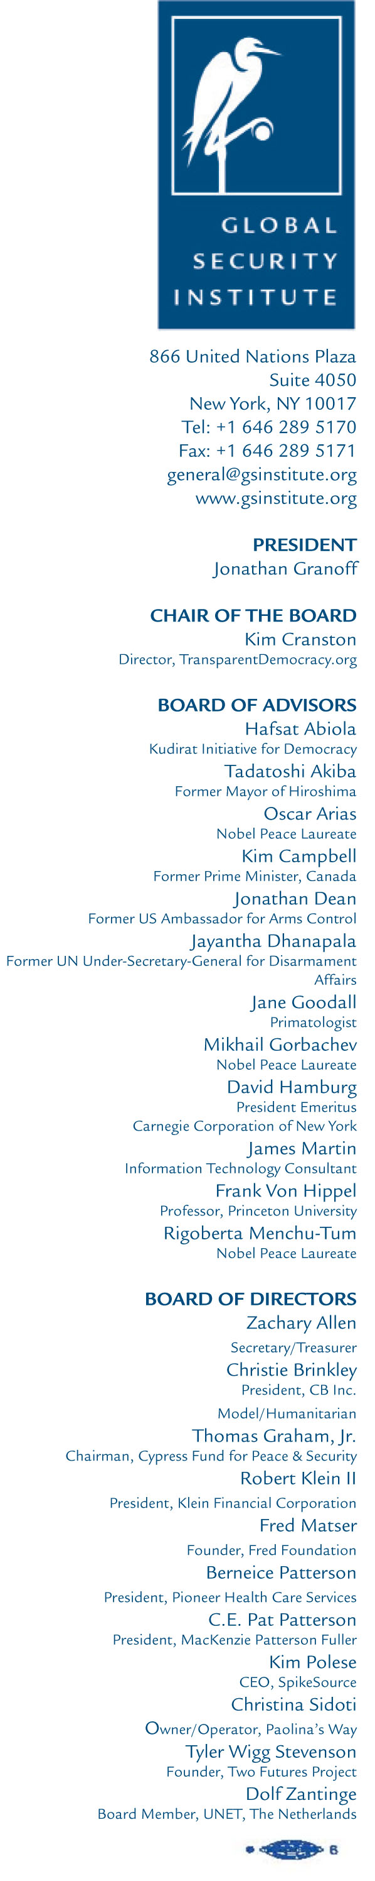
The Norwegian Example
Norway received a windfall of profits from fossil fuels and decided that it should not squander the money but invest it for future generations. The fund is now is excess of $750 Billion and is the largest sovereign wealth fund in Europe. It is an example of being wise, doing good, and doing well.
In the autumn of 2002, the Government appointed a committee to propose ethical guidelines for the Government Petroleum Fund. As the Graver fund reports: The ethical guidelines for the Government Petroleum Fund are based on two premises: “The Government Petroleum Fund is an instrument for ensuring that a reasonable portion of the country’s petroleum wealth should benefit future generations. The financial wealth must be managed with a view to generating a sound return in the long term, which is contingent on sustainable development in the economic, environmental and social sense. The Fund’s financial interests should be consolidated by using the Fund’s ownership interests to promote sustainable development. The Government Petroleum Fund should not make investments which constitute an unacceptable risk that the Fund may contribute to unethical acts or omissions, such as violations of fundamental humanitarian principles, serious violations of human rights, gross corruption or severe environmental degradation.”
Accordingly, the Fund implemented the following mechanisms to implement the Ethical Guidelines:
• Exercise of ownership rights in order to promote long-term financial returns based on the UN’s Global Compact and the OECD Guidelines for Corporate Governance and for Multinational Enterprises. • Negative screening of companies from the investment universe that either themselves, or through entities they control, produce weapons that through normal use may violate fundamental humanitarian principles. • Exclusion of companies from the investment universe where there may be an unacceptable risk of contributing to: • Serious or systematic human rights violations, such as murder, torture, deprivation of liberty, forced labor, the worst forms of child labor and other child exploitation • Grave breaches of individual rights in situations of war or conflict Severe environmental degradation • Gross corruption • Other particularly serious violations of fundamental ethical norms • The moral underpinnings of such an initiative are well-established.
The Norwegian Ministry of Foreign Affairs and its Parliament are proud of this project. They should be. It is an inspiration for those who care about a sustainable future.
RESOURCES
A summary of the Guidelines and Mechanism implemented by the Norwegian Government: http://www.regjeringen.no/en/dep/fin/Selected-topics/the-governmentpension-fund/responsible-investments/The-Graver-Committee---documents/The-Graver-Committee-and-Ethical-Guideli.html? id=434926# Longer version of the Norwegian Government’s White Paper outlining the guidelines: http://www.regjeringen.no/en/dep/fin/Selected-topics/the-government-pensionfund/responsible-investments/The-Graver-Committee---documents/Report-on-ethicalguidelines. html? id=420232
What We Should Do
There are many people who are passionate about protecting the environment, people, and rights and obtain health, security and ensure freedom. When our energies are coordinated we will change the political dialogue to a new set of realistic values and thus policies consistent with a sustainable future. We need examples of practices that can succeed in giving people back a sense of empowerment. Cynicism and apathy are dangerous but activism and success enlivens the spirit.
It is inspirational that a secular state, Norway, has advanced the moral imperative of sustainability in the interest of this and future generations. For those who believe that obligations to honor the creation arise from duties toward the Creator or a sense of responsibility to future generations what Norway has done is inspirational.
Institutions with a moral mandate, especially educational and religions institutions, can be persuaded to bring their values and investment policies into coherence. Investments in companies that benefit from environmental degradation and weapons of indiscriminate effect can be moved into industries aligned with enterprises that advance sustainable practices, or at least do no harm.
An advocacy project on responsible investing will charge the debate and give people in these institutions a proper sense of their moral agency.
This will also help fuel better industries. We can stimulate and facilitate a responsible investment for a sustainable future campaign in educational and religious institutions. This will stimulate engagement of millions of individuals worldwide and raise awareness considerably.
Using the Norwegian pension fund can serve as an example for rational and economically successful guidelines, The campaign will put forward the proposition that morally founded institutions must not invest in such a manner as to encourage activities which are against sustainability. It will advance the idea that we have duties to future generations and that environmentally irresponsible practices and the use of weapons of indiscriminate effect (land mines, cluster munitions, nuclear, biological and chemical weapons) are morally and practically unsustainable.
There is already a widely recognized movement to advance environmentally sustainable business practices and, as the Norwegians have so insightfully pointed out, there is a relationship in values and practice to the growing movement to eliminate weapons of indiscriminate effect, especially nuclear weapons.
We must now put into place legal, verifiable, and enforceable mechanisms based on our shared moral values to outlaw all weapons of indiscriminate effect. Chemical and biological weapons have been so classified, and nuclear weapons must become so. Raising public awareness by advocacy for practical change will help. Causing millions to take a position and engage will stimulate such awareness.
Destroying the very climate of the planet through greed cannot be justified by any morally based institution and their investments should reflect this truth.
A morally-based investment campaign will raise consciousness and be of benefit to socially responsible financial institutions as well. It will amplify the engagement of citizens in the security debate.

If you are interested in being part of this endeavor please contact me directly.

Respectfully
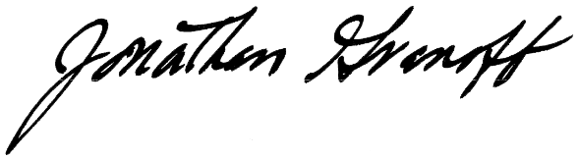
Jonathan Granoff, President
Cell 484 620 4967

